New Europe
Automotive Conferences
Prague – Winter Budapest – Spring
Katowice – Summer Munich - Autumn
Four Seasonal Forums across CEE region

where suppliers meet

Germany Austria Czech Republic Slovakia Poland
Hungary Turkey Slovenia Romania Bulgaria
Croatia Serbia BIH Ukraine

Overview
Sponsorship packages

Agenda

Networking

Branding

Supplier Meetings

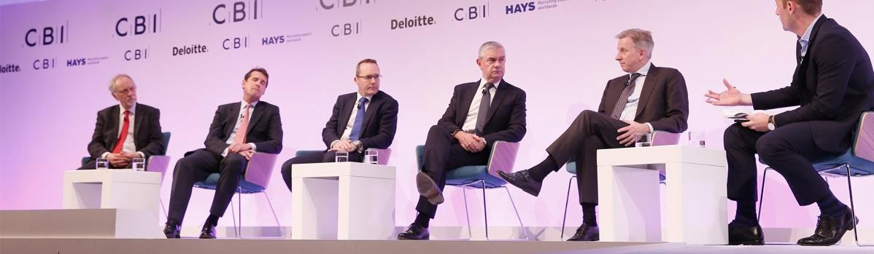
Contact: Adam Samar, Head of Partnerships
London tel: +447867026250 / +447867026251 / Adam.Samar@NewEuropeAuto.com

Your company can play a key role in Central Europe’s auto manufacturing. With your help the regional manufacturers can grow, increase productivity, output, and margins. New technologies, services and engineering solutions providers are as critical for CEE as the hundreds of thousands of engineering and technical workers employed in the region.
Central Europe’s largest
Conference & Purchasing Event
For automotive professionals
Marketing Campaign

Delegates by sector and by country

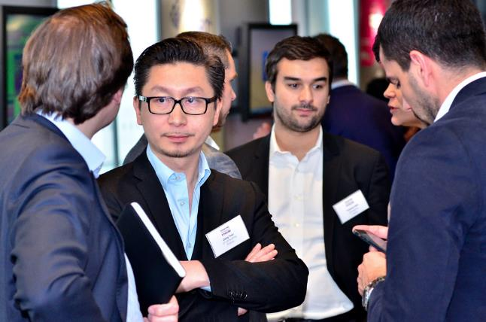
Our marketing campaign is aimed at:
Creating high-level business leads for you
Create new business opportunities
Increase your company’s profile
From the moment you confirm your participation in our Conference as a sponsor, we begin to provide you with outstanding marketing opportunities.

The conference programme incorporates interactive formats, such as panel debates and live interviews to ensure you are both informed and entertained.

A lively networking programme ensures that you have ample opportunity to network and share best practices with colleagues from the Central European community.
On average we have 10-12 sponsors yearly.

Contact:
Adam Samar, London, UK
M. +44 74 2550 2350
E. contact@NewEuropeAuto.com
New Europe Automotive and our conference has grown into a community network

BECOME A SPONSOR and be a part of the region’s audience by creating trust
Gain access to the in-depth requirements of manufacturers from 14 countries
Opportunity to fulfil them with your expertise or services

Package includes
Lead
Sponsor

+ Session Speaker
+ Free Delegates
+ Exhibition space
+ Video interview
+ Exclusivity
for full prices – call us

During Conference
  - Session Speaking slot:
  - highly visible speaking slot within one of conference sessions
  - speaking time lasts 10 or 15 minutes and provides an opportunity to demonstrate your company’s expertise
  - Free places: we will provide you with 4 free delegate places (in addition to speaker’s place)
  - Exhibition space: we will provide you with 3x2 m² / 3x1 m² area in the networking and exhibition foyer outside auditorium. Here you can set up a Stand to use for discussions and meetings
  - Video interview: Our Videographer will film a 3-4 minute high-quality interview with your Manager (filming, editing & montage) suitable for follow-up marketing, website, YouTube or Linkedin
  - Exclusivity: You will have exclusivity in this category. Other Sponsors will not be invited to sponsor at this level
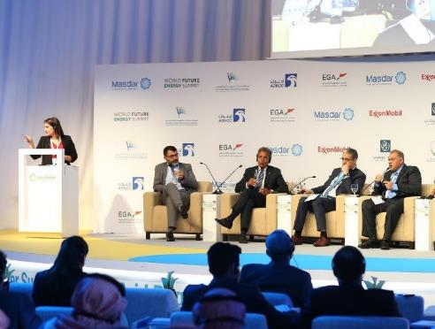
  - Signage: we will make visible your support of the conference through signage in the conference hall, where a slide with your company name & logo will be displayed on the front screen (Exclusive to Premier and Lead Sponsors)..

  - Logo: Your logo will be included on a) the stage banner in the conference hall, b) roll-up banner at Registration desk, and c) on screen projector cover-slides during the event

Before Conference
  - After paying the sponsorship fee you will receive an updated delegate list one week before the event. This enables you to plan your strategic networking during the event and to maximise your contacts
- Marketing Campaign: Your logo & company description
  - will be displayed on our website together with your URL link - for 12 months
  - will be displayed in all our promotional materials, over the whole marketing campaign - for 5 months
- More delegate places:
  - you can buy more delegate places at a 25% discount
  - your external partners or potential clients are also entitled to 25% discount (we can inform them via emails)
- Your participation will be advertised via emailings to our database of senior automotive contacts
  - Visibility: Our website is accessible via all search engines and industry sector sites, thus ensuring marketing of your company on a larger scale

After
  - After the event, you will receive a copy of the full and final delegate list with contact details (except e-mail addresses) for your future marketing campaigns..

Package includes
Lead Session Speaker & Chair

+ Session Speaker
+ Free Delegates
+ Exhibition space
+ Video interview
+ Exclusivity
for full prices – call us

During Conference
  - Shape the Session agenda:
  - Chairing & Speaking: you can both chair and/or speak in your chosen session (agreed with Conference Director). Session: You will help to shape the Session panel’s agenda, co-invite other speakers and discussion panellists (agreed with Conference Director). Exclusivity: Your company will be the only sponsor in this session
  - Session Speaker:
  - highly visible speaking slot within one of conference sessions
  - speaking time lasts 10 or 15 minutes and provides an opportunity to demonstrate your company’s expertise
  - Free places: we will provide you with 3 free delegate places (in addition to speaker’s place)
  - Session sponsor’s logo: your company logo will be displayed in the conference hall during your sponsored session
  - Logo: Your logo will be included.. on a) the stage banner in the conference hall, b) roll-up banner at Registration desk, and c) on screen projector cover-slides during the event

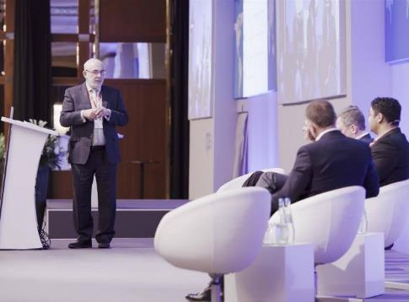
  - Video interview: Our Videographer will film a 3-4 minute high-quality interview with your Manager (filming, editing & montage) suitable for follow-up marketing, website, YouTube or Linkedin
  - Materials: You have an option to distribute marketing materials..

  - Optional (additions, with discount):
  - Exhibition space: a 3x2 sq metres area in the networking and exhibition foyer outside auditorium (Stand can act as focal point for discussions and delegate meetings)

Before Conference
- Marketing Campaign: Your logo & company description
  - will be displayed on our website together with your URL link - for 12 months
  - will be displayed in all our promotional materials, over the whole marketing campaign - for 5 months
- More delegate places:
  - you can buy more delegate places at a 25% discount
  - your external partners or potential clients are also entitled to 25% discount (we can inform them via emails)
- Your participation will be advertised via emailings to our database of senior automotive contacts
  - Visibility: Our website is accessible via all search engines and industry sector sites, thus ensuring marketing of your company on a larger scale

Package includes
Associate Speaker Sponsor

+ Session Speaker
+ 2 Free Delegates
+ Video Interview

for full prices – call us
15-minute presentation
for full prices – call us
10-minute presentation

During Conference
  - Session Speaker:
  - highly visible speaking slot within one of conference sessions
  - speaking time lasts 10 or 15 minutes and provides an opportunity to demonstrate your company’s expertise
  - Free places: we will provide you with 2 free delegate places (in addition to speaker’s place)
  - Logo: Your logo will be included on a) the stage banner in the conference hall, b) roll-up banner at Registration desk, and c) on screen projector cover-slides during the event
  - Video interview: Our Videographer will film a 3-4 minute high-quality interview with your Manager (filming, editing & montage) suitable for follow-up marketing, website, YouTube or Linkedin

  - Optional (additions, with discount):
  - Exhibition space: we can provide a 3x2 m² / 3x1 m² area in the networking and exhibition foyer outside auditorium. Here you can set up a Stand to use for discussions and meetings

Before Conference
- Marketing Campaign: Your logo & company description
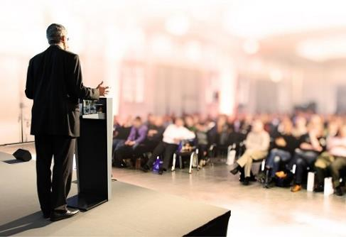
  - will be displayed on our website together with your URL link - for 12 months

  - will be displayed in all our promotional materials, over the whole marketing campaign - for 5 months
- More delegate places:
  - you can buy more delegate places at a 25% discount
  - your external partners or potential clients are also entitled to 25% discount (we can inform them via emails)
- Your participation will be advertised via emailings to our database of senior automotive contacts
- Visibility: Our website is accessible via all search engines and industry sector sites, thus ensuring marketing of your company on a larger scale

Package includes
Knowledge Partner

+ Session Speaker or Moderator
+ Free Delegates
+ Exhibition
+ Exclusivity
+ Video interview
for full prices – call us

During Conference

  - Session Speaker:
  - highly visible speaking slot within one of conference sessions
  - speaking time lasts 10 or 15 minutes and provides an opportunity to demonstrate your company’s expertise
  - Session Moderator: alternatively, you can choose to moderate one of the conference sessions (agreed with event director).
  - Free places: we will provide you with 2 free delegate places (in addition to speaker’s place)
  - Knowledge Partner Logo: will be included in all marketing materials advertising you as ‘knowledge partner’.
  - Reports & Brochures: You can include company reports, brochures, analytics or other materials for the delegates
  - Exclusivity: no other company will be invited as ‘knowledge partner’ giving you exclusivity in this category
  - Logo: Your logo will be included on a) the stage banner in the conference hall, b) roll-up banner at Registration desk, and c) on screen projector cover-slides during the event
  - Video interview: Our Videographer will film a 3-4 minute high-quality interview with your Manager (filming, editing & montage) suitable for follow-up marketing, website, YouTube or Linkedin

Before Conference

- Marketing Campaign: Your logo & company description
  - will be displayed on our website together with your URL link - for 12 months
  - will be displayed in all our promotional materials, over the whole marketing campaign - for 5 months
- More delegate places:
  - you can buy more delegate places at a 25% discount
  - your external partners or potential clients are also entitled to 25% discount (we can inform them via emails)
- Your participation will be advertised via emailings to our database of senior automotive contacts
  - Visibility: Our website is accessible via all search engines and industry sector sites, thus ensuring marketing of your company on a larger scale
Package includes
Premier
Partner

+ Exclusivity & Logos
+ Exhibition space
+ Planning for meetings
+ Free Delegates
+ Video interview
for full prices – call us

During Conference
  - Exclusivity: You will be positioned as the premier event partner and will have exclusivity in this category. Your position as the primary partner of the event will be reflected in both programme and branding benefits
  - Logo: will be placed on all conference lanyards
  - Logo: will be placed on all pads and pens of the conference
  - Exhibition space: we will provide you with 3x2 m² / 3x1 m² area in the networking and exhibition foyer outside auditorium. Here you can set up a Stand to use for discussions and meetings
  - Free places: we will provide you with 5 free delegate places
  - We will make visible your support of the conference through signage in the conference hall where your logo will have a prominent position behind the speaker podium. (Exclusive to lead and premier sponsors)
  - Logo: Your logo will be included on a) the stage banner in the conference hall, b) roll-up banner at Registration desk, and c) on screen projector cover-slides during the event
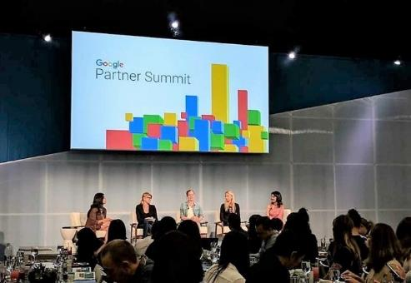
  - Video interview: Our Videographer will film a 3-4 minute high-quality interview with your Manager (filming, editing & montage) suitable for follow-up marketing, website, YouTube or Linkedin

Before Conference
  - Planning: after paying your sponsorship fee you will receive an updated delegate list one week before the event. This enables you to plan your networking in advance and to maximise results
- Marketing Campaign: Your logo & company description
  - will be displayed on our website together with your URL link - for 12 months
  - will be displayed in all our promotional materials, over the whole marketing campaign - for 5 months
- More delegate places:
  - you can buy more delegate places at a 25% discount
  - your external partners or potential clients are also entitled to 25% discount (we can inform them via emails)
- Your participation will be advertised via emailings to our database of senior automotive contacts
  - Visibility: Our website is accessible via all search engines and industry sector sites, thus ensuring marketing of your company on a larger scale

After the Conference
  - After the event, you will receive a copy of the full and final delegate list with contact details (except e-mail addresses) for your future marketing campaigns

Package includes
Master Class
Sponsor

+ Hosting Master Class
+ Co-creating Programme
+ Free Delegates
+ Exclusivity
+ Video interview
for full prices – call us

During Conference
  - Afternoon Master Class:
  - Afternoon: You can host a master class on the afternoon of the second day of the conference. This will provide you with a unique opportunity to showcase your expertise to a highly targeted and interested audience.
  - Panel Topic (Programme): you will be able to invite additional panellists to join the briefing (agreed with Conference Director)
  - Format: You will be free to determine the session’s format: Training / Roundtable / Presentations / Debate / Multi-Speakers. Example: roundtables encourage discussion
  - Exclusivity: exclusive branding as hosts of the Master Class
  - Free places: we will provide you with 2 free delegate places (in addition to speaker’s place)
  - Logo: Your logo will be included on a) the stage banner in the conference hall, b) roll-up banner at Registration desk, and c) on screen projector cover-slides during the event

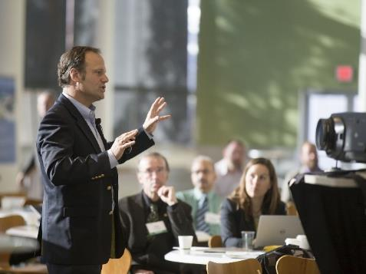
  - Video interview: Our Videographer will film a 3-4 minute high-quality interview with your Manager (filming, editing & montage) suitable for follow-up marketing, website, YouTube or Linkedin

  - Optional (additions, with discount):
  - Exhibition space: we can provide a 3x2 m² / 3x1 m² area in the networking and exhibition foyer outside auditorium. Here you can set up a Stand to use for discussions and meetings

Before Conference
- Marketing Campaign: Your logo & company description
  - will be displayed on our website together with your URL link - for 12 months
  - will be displayed in all our promotional materials, over the whole marketing campaign - for 5 months
- More delegate places:
  - you can buy more delegate places at a 25% discount
  - your external partners or potential clients are also entitled to 25% discount (we can inform them via emails)
- Your participation will be advertised via emailings to our database of senior automotive contacts
  - Visibility: Our website is accessible via all search engines and industry sector sites, thus ensuring marketing of your company on a larger scale

Package includes
Business Breakfast
Sponsor

+ Hosting Business Breakfast
+ Creating Programme
+ Free Delegates
+ Exclusivity
+ Video interview
for full prices – call us

During Conference
  - Business Breakfast:
  - Morning: One-hour business breakfast on the second day of the conference offers an opportunity to showcase your expertise to a highly targeted audience
  - Panel Topic (Programme): You will have the option of inviting additional panellists to join the briefing (agreed with Conference Director)
  - Moderating: You will lead discussions, can make a presentation and take questions from the floor
  - Session Speaker:
  - highly visible speaking slot within one of conference sessions
  - speaking time lasts 10 or 15 minutes and provides an opportunity to demonstrate your company’s expertise
  - Branding: You will have exclusive branding exposure for the business briefing – to include banner, breakfast menu etc.
  - Free places: we will provide you with 2 free delegate places (in addition to speaker’s place)
  - Logo: Your logo will be included on a) the stage banner in the conference hall, b) roll-up banner at Registration desk, and c) on screen projector cover-slides during the event
  - Video interview: Our Videographer will film a 3-4 minute high-quality interview with your Manager (filming, editing & montage) suitable for follow-up marketing, website, YouTube or Linkedin

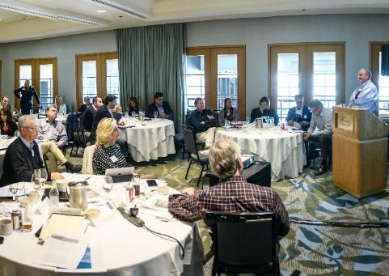
  - Optional (additions, with discount):
  - Exhibition space: we will provide you with 3x2 m² / 3x1 m² area in the networking and exhibition foyer outside auditorium. Here you can set up a Stand to use for discussions and meetings

Before Conference
- Marketing Campaign: Your logo & company description
  - will be displayed on our website together with your URL link - for 12 months
  - will be displayed in all our promotional materials, over the whole marketing campaign - for 5 months
- More delegate places:
  - you can buy more delegate places at a 25% discount
  - your external partners or potential clients are also entitled to 25% discount (we can inform them via emails)
- Your participation will be advertised via emailings to our database of senior automotive contacts
    - Visibility: Our website is accessible via all search engines and industry sector sites, thus ensuring marketing of your company on a larger scale

Package includes
Corporate
Partner
for full prices – call us

+Session Speaker
+5 to 10 Free Delegates
+ Meetings Support
+Networking support

During Conference

  - Free places: We will provide you with 5 -10 free delegate places
  - We will provide you with access to a meeting room where you can hold round table discussions with your prospective clients.
  - Networking meetings: We will help you arrange business meetings (up to 5 meetings) with key participants - speakers and delegates
  - Invitations: we will invite your target companies to attend the conference. If you wish them to get free places - they can either use your free tickets or buy theirs with 25% discount
  - Session Speaker:
  - highly visible speaking slot within one of conference sessions
  - speaking time lasts 10 or 15 minutes and provides an opportunity to demonstrate your company’s expertise
  - Logo: Your logo will be included on a) the stage banner in the conference hall, b) roll-up banner at Registration desk, and c) on screen projector cover-slides during the event
  - Video interview: Our Videographer will film a 3-4 minute high-quality interview with your Manager (filming, editing & montage) suitable for follow-up marketing, website, YouTube or Linkedin

Before Conference
- Marketing Campaign: Your logo & company description
  - will be displayed on our website together with your URL link - for 12 months
  - will be displayed in all our promotional materials, over the whole marketing campaign - for 5 months
- More delegate places:
  - you can buy more delegate places at a 25% discount
  - your external partners or potential clients are also entitled to 25% discount (we can inform them via emails)
- Your participation will be advertised via emailings to our database of senior automotive contacts
- Visibility: Our website is accessible via all search engines and industry sector sites, thus ensuring marketing of your company on a larger scale

Exhibition Sponsor
Exhibition
Sponsor
for full prices – call us
larger space: 3 x 2m²
+ 2 free delegates

for full prices – call us
smaller space: 3 x 1m²
+ 2 free delegates

Large Exhibition Sponsor
for full prices – call us
larger space: 3 x 2m2

+ 4 free delegates
+ Dedicated Video interview

During Conference
  - Exhibition space: we will provide you with 3x2 m² / 3x1 m² area in the networking and exhibition foyer outside auditorium. Here you can set up a Stand to use for discussions and meetings
  - Free places: we will provide you with 2 free delegate places
  - Logo: Your logo will be included on a) the stage banner in the conference hall, b) roll-up banner at Registration desk, and c) on screen projector cover-slides during the event

Large Exhibition Sponsor

During Conference
  - Exhibition space: we will provide you with 3x2 m² / 3x1 m² area in the networking and exhibition foyer outside auditorium. Here you can set up a Stand to use for discussions and meetings
  - Free places: we will provide you with 4 free delegate places
  - Video interview: Our Videographer will film a 3-4 minute high-quality interview with your Manager (filming, editing & montage) suitable for follow-up marketing, website, YouTube or Linkedin

  - Logo: Your logo will be included on a) the stage banner in the conference hall, b) roll-up banner at Registration desk, and c) on screen projector cover-slides during the event

Before Conference
- Marketing Campaign: Your logo & company description
  - will be displayed on our website together with your URL link - for 12 months

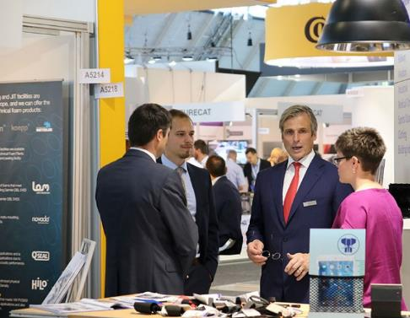
  - will be displayed in all our promotional materials, over the whole marketing campaign - for 5 months
- More delegate places:
  - you can buy more delegate places at a 25% discount
  - your external partners or potential clients are also entitled to 25% discount (we can inform them via emails)
- Your participation will be advertised via emailings to our database of senior automotive contacts
- Visibility: Our website is accessible via all search engines and industry sector sites, thus ensuring marketing of your company on a larger scale

VIP Lunch Sponsor
for full prices – call us

Package includes

During Conference
  - Your welcome address of 5 minutes (approx) at Formal lunch.. This is an excellent opportunity for undivided attention to our senior audience..
  - Two top tables at Formal lunch.. will be reserved for your company. At your request, we can send out personal invitations to any speakers or delegates you wish to entertain..
  - To make the most of your networking opportunities at Formal lunch, you can also have an extra number of personnel or guests at the lunch..
  - Lunch menu: Your company logo will be printed on the menu, acting as a reminder of your support of the lunch.
  - Video interview: Our Videographer will film a 3-4 minute high-quality interview with your Manager (filming, editing & montage) suitable for follow-up marketing, website, YouTube or Linkedin
  - Signage with your name and company logo will be placed prominently at the lunch.
  - Logo: Your logo will be included on a) the stage banner in the conference hall, b) roll-up banner at Registration desk, and c) on screen projector cover-slides during the event
  - Presents or company gifts can be given to lunch participants

  - Optional (additions, with discount):
  - Session Speaker: slot takes 10-15 minutes and gives you an opportunity to demonstrate your company’s expertise, or
  - Exhibition space: we can provide a 3x2 m² / 3x1 m² area in the networking and exhibition foyer outside auditorium. Here you can set up a Stand to use for discussions and meetings

Before Conference
- Marketing Campaign: Your logo & company description
  - will be displayed on our website together with your URL link - for 12 months
  - will be displayed in all our promotional materials, over the whole marketing campaign - for 5 months
- More delegate places:
  - you can buy more delegate places at a 25% discount
  - your external partners or potential clients are also entitled to 25% discount (we can inform them via emails)
- Your participation will be advertised via emailings to our database of senior automotive contacts
- Visibility: Our website is accessible via all search engines and industry sector sites, thus ensuring marketing of your company on a larger scale

Exclusive
Speaker Zone
Sponsor
for full prices – call us

Package includes

During Conference
  - Branding: Exclusive branding in the reserved speakers’ zone Banners with your company logo announcing you as VIP Speaker Zone Sponsor (supplied by us). This will be visibly placed at the entrance to and inside the speaker zone
  - Area Exclusivity: Only speakers and your company colleagues will have access to this area
  - Free places: we will provide you with 2 free delegate places
  - We will provide your company with space for your exhibition space or roll up banner within the speaker zone. You will be the only sponsor to be offered exhibition space in this area
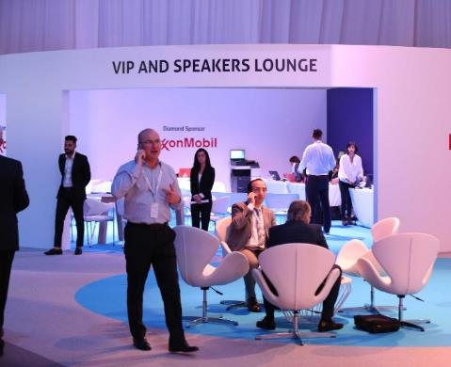
  - Logo: Your logo will be included on a) the stage banner in the conference hall, b) roll-up banner at Registration desk, and c) on screen projector cover-slides during the event
  - Video interview: Our Videographer will film a 3-4 minute high-quality interview with your Manager (filming, editing & montage) suitable for follow-up marketing, website, YouTube or Linkedin

  - Optional (additions, with discount)
  - Session Speaker: slot takes 10-15 minutes and gives you an opportunity to demonstrate your company’s expertise, or
  - Exhibition space: we can provide a 3x2 m² / 3x1 m² area in the networking and exhibition foyer outside auditorium. Here you can set up a Stand to use for discussions and meetings

Before Conference
- Marketing Campaign: Your logo & company description
  - will be displayed on our website together with your URL link - for 12 months
  - will be displayed in all our promotional materials, over the whole marketing campaign - for 5 months
- More delegate places:
  - you can buy more delegate places at a 25% discount
  - your external partners or potential clients are also entitled to 25% discount (we can inform them via emails)
- Your participation will be advertised via emailings to our database of senior automotive contacts
- Visibility: Our website is accessible via all search engines and industry sector sites, thus ensuring marketing of your company on a larger scale

Coffee House

During Conference
Coffee House Sponsor
for full prices – call us
or

Juice Bar Sponsor
for full prices – call us
  - Exhibition space: we will provide you with 3x2 m² / 3x1 m² area in the networking and exhibition foyer outside auditorium. Here you can set up a Stand to use for discussions and meetings
  - Logo: will feature throughout the Coffee House from the specially prepared signs to barista aprons and even coffee cup sleeves.
  - Logo: Your logo will be included on a) the stage banner in the conference hall, b) roll-up banner at Registration desk, and c) on screen projector cover-slides during the event
  - Free places: we will provide you with 2 free delegate places
  - Video interview: Our Videographer will film a 3-4 minute high-quality interview with your Manager (filming, editing & montage) suitable for follow-up marketing, website, YouTube or Linkedin

Juice Bar

During Conference
  - Exhibition space: we will provide you with 3x2 m² / 3x1 m² area in the networking and exhibition foyer outside auditorium. Here you can set up a Stand to use for discussions and meetings
  - Bar logo: Your logo will feature throughout the Juice Bar from the specially prepared signs on the front panel of the bar and backdrop to the juice glasses themselves.
  - Free places: we will provide you with 2 free delegate places
  - Logo: Your logo will be included on a) the stage banner in the conference hall, b) roll-up banner at Registration desk, and c) on screen projector cover-slides during the event
  - Video interview: Our Videographer will film a 3-4 minute high-quality interview with your Manager (filming, editing & montage) suitable for follow-up marketing, website, YouTube or Linkedin

  - Optional (additions, with discount)
  - Session Speaker: speaking slot takes 10-15 minutes and gives you an opportunity to demonstrate your company’s expertise

Before Conference
- Marketing Campaign: Your logo & company description
  - will be displayed on our website together with your URL link - for 12 months
  - will be displayed in all our promotional materials, over the whole marketing campaign - for 5 months
- More delegate places:
  - you can buy more delegate places at a 25% discount
  - your external partners or potential clients are also entitled to 25% discount (we can inform them via emails)
- Your participation will be advertised via emailings to our database of senior automotive contacts
- Visibility: Our website is accessible via all search engines and industry sector sites, thus ensuring marketing of your company on a larger scale

Evening Cocktail Sponsor
for full prices – call us

Package includes

During Conference
  - Session Speaking slot:
  - Highly visible speaking slot within one of conference sessions
  - Speaking time lasts 10 or 15 minutes and provides an opportunity to demonstrate your company’s expertise

  - Exhibition space: we will provide you with 3x2 m² / 3x1 m² area in the networking and exhibition foyer outside auditorium. Here you can set up a Stand to use for discussions and meetings
  - Speech: Your welcome address of 5 minutes (approx)

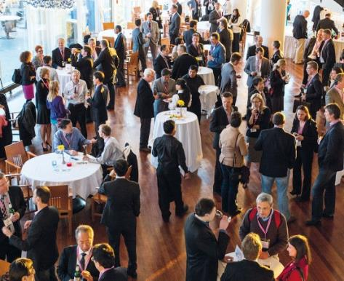
  - Branding: Your logo will feature in the vicinity of the cocktail bar and will include special signage, menu, cocktail sticks and waiter jackets
  - Free places: we will provide you with 3 free delegate places
  - Logo: Your logo will be included on a) the stage banner in the conference hall, b) roll-up banner at Registration desk, and c) on screen projector cover-slides during the event

  - Optional (additions, with discount)
  - Video interview: Our Videographer will film a 3-4 minute high-quality interview with your Manager (filming, editing & montage) suitable for follow-up marketing, website, YouTube or Linkedin

Before Conference
- Marketing Campaign: Your logo & company description
  - will be displayed on our website together with your URL link - for 12 months
  - will be displayed in all our promotional materials, over the whole marketing campaign - for 5 months
- More delegate places:
  - you can buy more delegate places at a 25% discount
  - your external partners or potential clients are also entitled to 25% discount (we can inform them via emails)
- Your participation will be advertised via emailings to our database of senior automotive contacts
- Visibility: Our website is accessible via all search engines and industry sector sites, thus ensuring marketing of your company on a larger scale

Lanyards
Sponsor

for full prices – call us

Package includes

During Conference
  - Your company logo will be printed.. on conference Lanyards or Badges. This will provide your company with an exceptionally high level of visibility as participants will wear badges for the duration of the conference.
  - Exhibition space: we will provide you with 3x2 m² / 3x1 m² area in the networking and exhibition foyer outside auditorium. Here you can set up a Stand to use for discussions and meetings
  - Free places: we will provide you with 2 free delegate places
  - Logo: Your logo will be included on a) the stage banner in the conference hall, b) roll-up banner at Registration desk, and c) on screen projector cover-slides during the event

  - Optional (additions, with discount):
  - Session Speaker: speaking slot takes 10-15 minutes and gives you an opportunity to demonstrate your company’s expertise
  - Exhibition space: we can provide a 3x2 m² / 3x1 m² area in the networking and exhibition foyer outside auditorium. Here you can set up a Stand to use for discussions and meetings
  - Video interview: Our Videographer will film a 3-4 minute high-quality interview with your Manager (filming, editing & montage) suitable for follow-up marketing, website, YouTube or Linkedin

Before Conference
- Marketing Campaign: Your logo & company description
  - will be displayed on our website together with your URL link - for 12 months
  - will be displayed in all our promotional materials, over the whole marketing campaign - for 5 months
- More delegate places:
  - You can buy more delegate places at a 25% discount
  - your external partners or potential clients are also entitled to 25% discount (we can inform them via emails)
- Your participation will be advertised via emailings to our database of senior automotive contacts
- Visibility: Our website is accessible via all search engines and industry sector sites, thus ensuring marketing of your company on a larger scale

During Conference
Conference
Bags Sponsor

or

Paper & Pens
Sponsor

or

Custom Gifts
Sponsor
for full prices – call us

Conference Bags
  - Bags logo: Your company logo & website will be displayed on all conference bags to be placed onto delegate desks so that your company is associated with the event. Bags serve as long-term promotion, as delegates often keep them and use them in daily life

Paper & Pens
  - Notepads with your logo will be supplied to conference delegates
  - Pens: delegates will also be provided with pens featuring your company logo and website (supplied by us). Notepads and pens will be placed on delegate tables to ensure branding exposure

Custom Gifts
  - Your company name & logo will be displayed on all gift presentation boxes.

All
  - Reports & Brochures: You can include company reports, brochures or other materials in the conference bags
  - Free places: we will provide you with 3 free delegate places
  - Logo: Your logo will be included on a) the stage banner in the conference hall, b) roll-up banner at Registration desk, and c) on screen projector cover-slides during the event

  - Optional (additions, with discount):
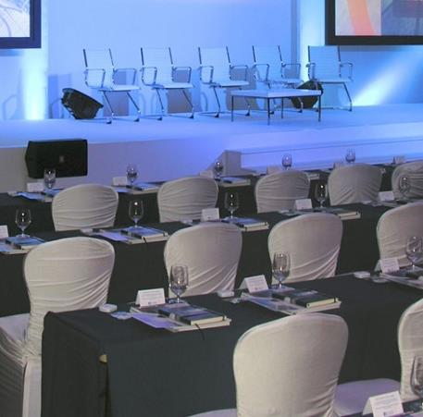
  - Session Speaker: speaking slot takes 10-15 minutes and gives you an opportunity to demonstrate your company’s expertise
  - Exhibition space: we can provide you with 3x2 m² / 3x1 m² area in the networking and exhibition foyer outside auditorium. Here you can set up a Stand to use for discussions and meetings
  - Video Interview

Before Conference
- Marketing Campaign: Your logo & company description
  - will be displayed on our website together with your URL link - for 12 months
  - will be displayed in all our promotional materials, over the whole marketing campaign - for 5 months
- More delegate places:
  - You can buy more delegate places at a 25% discount
  - your external partners or potential clients are also entitled to 25% discount (we can inform them via emails)
- Your participation will be advertised via emailings to our database of senior automotive contacts
- Visibility: Our website is accessible via all search engines and industry sector sites, thus ensuring marketing of your company on a larger scale

Package includes
Registration Desk
Sponsor
+ roll up banner
+ Logo & Branding on Registration Desk
+ your gifts
For full prices – call us

During Conference
  - Your company logo will be displayed on the wall behind the Official Registration desk
  - Gifts: You can place marketing materials and small corporate gifts (to be provided by sponsor) on Official Registration desk
  - Free places: We will provide you with 2 free delegate places
  - Roll-up Banner: We will provide space for your roll-up banner close to the Registration desk.
  - We will include your A5 advertisement in the welcome pack.
  - Logo: Your logo will be included on a) the stage banner in the conference hall, b) roll-up banner at Registration desk, and c) on screen projector cover-slides during the event
  - Video interview: Our Videographer will film a 3-4 minute high-quality interview with your Manager (filming, editing & montage) suitable for follow-up marketing, website, YouTube or Linkedin

  - Optional (additions, with discount):
  - Exhibition space: we can provide you with 3x2 m² / 3x1 m² area in the networking and exhibition foyer outside auditorium. Here you can set up a Stand to use for discussions and meetings

Before Conference
- Marketing Campaign: Your logo & company description
  - will be displayed on our website together with your URL link - for 12 months
  - will be displayed in all our promotional materials, over the whole marketing campaign - for 5 months
- More delegate places:
  - You can buy more delegate places at a 25% discount
  - your external partners or potential clients are also entitled to 25% discount (we can inform them via emails)
- Your participation will be advertised via emailings to our database of senior automotive contacts
- Visibility: Our website is accessible via all search engines and industry sector sites, thus ensuring marketing of your company on a larger scale

USB Sticks
USB Sticks

or

Branded Water Bottle
Sponsor

for full prices – call us

During Conference
  - USB sticks: featuring your company name, logo & website, providing your company with branding & name recognition – Sourced by us
  - Free places: we will provide you with 2 free delegate places
  - Logo: Your logo will be included on a) the stage banner in the conference hall, b) roll-up banner at Registration desk, and c) on screen projector cover-slides during the event

Branded Water

During Conference
  - Logo on water bottles: These will be made available to participants both in the conference hall and exhibition hall providing your company with branding & name recognition – Sourced by us
  - Free places: we will provide you with 2 free delegate places
  - Logo: Your logo will be included on a) the stage banner in the conference hall, b) roll-up banner at Registration desk, and c) on screen projector cover-slides during the event

  - Optional (additions, with discount):
  - Exhibition space: we can provide you with 3x2 m² / 3x1 m² area in the networking and exhibition foyer outside auditorium. Here you can set up a Stand to use for discussions and meetings
  - Video interview: Our Videographer will film a 3-4 minute high-quality interview with your Manager (filming, editing & montage) suitable for follow-up marketing, website, YouTube or Linkedin

Before Conference
- Marketing Campaign: Your logo & company description
  - will be displayed on our website together with your URL link - for 12 months
  - will be displayed in all our promotional materials, over the whole marketing campaign - for 5 months
- More delegate places:
  - you can buy more delegate places at a 25% discount
  - your external partners or potential clients are also entitled to 25% discount (we can inform them via emails)
- Your participation will be advertised via emailings to our database of senior automotive contacts
- Visibility: Our website is accessible via all search engines and industry sector sites, thus ensuring marketing of your company on a larger scale

